**Project Report**



**North-South University**

Department of Electrical & Computer Engineering

**Senior Design Project**

**E-Sheba**

**Submitted To:** Dr. Shahnewaz Siddique (SNS1), Faculty, NSU

**Submitted By:** Group- 03, Section- 01

**Group Members:**

|  |  |
| --- | --- |
| **NAME** | **ID** |
| Md Abu Sayed Fahim | 1812534642 |
| Sifatulla | 1813317642 |
| Md Aminul Islam | 1721208 |
| Md. Shakawat Islam | 1712581642 |
| Saddam Hossain Tonmoy | 1711096611 |

**Submission Date:** 14th January 2022

**ABSTRACT**

We have created a web-based social media application as our project. With this project, our priority is to promote a platform for students and as well as for book lovers to get their books easily. The web platform that we have developed is dynamic, meaning we can add, remove or update any feature at any given time. We have added different features. We have created an extensive database design to ensure that the web app can be as dynamic as possible without the need for the platform to be shut down for maintenance when we update or add new features in the future. We realized that our product has a much greater scope of extension beyond the foundation laid in this project. The web platform that we have developed is based on the idea of an “E-commerce” platform. However, we have left room for the addition of more features in the future. Furthermore, our project shows promise to be capable enough to be used for a different kind of user. We want our users to use the platform’s features. We have named our web application “E-Sheba”.

**Introduction**

The health system of Bangladesh relies heavily on the government or the public sector for financing and setting overall policies and service delivery mechanisms. Generally, there exists a lot of govt. and private medical service providers in Bangladesh. The services of these medical organizations are at a good level but there are a few online medical systems in our country which are not enough for all kinds of solutions for patients. For example, “BdHealthSolution” is an online clinic for Bangladeshi people and provides online consultations and treatments using a remote doctor/patient interface. To upgrade the online medical system, we made up our mind to make a project named E-Sheba. E-Sheba is a system consisting of a lot of web pages that stands for Electronic Medicare. It is a complex web application containing a lot of tools that enable you to access your profiles, doctor and hospital details. This is a collaboration platform among citizens, doctors, and all hospitals in the country. That means the patients can get treatment and the doctor can digitally give treatment. And E-Sheba is the medium between them. If a patient gets their treatment with just a snap of fingers, it will add a new horizon of ease in our day-to-day life. Every citizen will have a medical id, every doctor will have a doctor id and every medical service provider will have their Medicare id. Through this, any citizen can get their treatment and related information. Therefore the main aim of E-Sheba is to ensure a very easier treatment procedure by just a Website. E-Sheba also will keep doctors, patients, and Medicenter in a touch. Now it is very much possible to communicate with the doctors, who are available at this moment by sitting at home through a video call. And people can get this facility by this website. So if you have a device that is enough to browse the internet and if you have the internet on your device then you can access any kind of medically related information by visiting E-Sheba (website). [1] [2]

**Motivation**

There exists at least one reason behind every good or bad thing. Most of the things had been done to get rid of some problems. That means when some problem occurs that makes our life complex then we make some solutions that make our life easier and flexible. So there is a lot of reasons behind the making of E-Sheba. And these reasons are nothing but some severe problems that we faced for a long time, which motivated us to create this web application. These reasons that motivated us are belowed:

1. Time Complexity: People go to the hospital when they need an immediate treatment to get rid of the diseases they are suffering from. Doctors suggest them to do a lot of tests and after making the tests people have to wait for a long time to get their test reports. If the patient’s house is far away from the hospital, then they have to suffer in the long run for this. Sometime they need to make a long journey only for the result. Watching this problem, we became agree to make this project.
2. Prescription problems: Sometimes patients go to the doctor without any previous prescriptions. It happens may be for loosing previous prescriptions or forgetting to bring with them. This hampers their proper treatment in many case. This grounds to make E-Sheba.
3. Medicine problem: Sometime people don’t find pharmacy at their nearest place or they don’t get their wanted medicine at nearest pharmacy. We will try to make sure that they will get their medicine from our pharmacy.
4. Unawareness about doctor & hospital: Many people goes to the hospital without knowing anything about doctors and hospital. Sometimes it happens that people go to the doctors who are not suitable for his/her disease. To overcome this problem we decided to make E-Sheba.
5. Doctor’s platform: Many doctors of our country remain jobless after completing their studies. So for giving them a good platform we determined to make E-Sheba.
6. Unable to get immediate service : People of our country don’t get services immediately when they need. So we are motivated to make something that will give all at once.

These are the main problems that motivated us to make E-Sheba.

**Objectives**

The main objective of our project is to make Bangladesh medical ecosystem more efficient and reliable and technical. That means the activities of medical system will be done in digital way. The first target is to collaborate this project with Bangladesh govt. and then ensure a medical ID as well as a medical profile for each citizen of our country. Alongside the citizen doctor and medical service provider’s id also will be ensured. The objective is to collaborate among the patients, the doctors and the medical service providers of the country. This project is also a patient monitoring system. That will store all information of patient in their profile and doctors can monitor it when it is needed. The most important thing is E-Sheba will reduce the time and trouble by saving their report and prescriptions in their profile. The test reports also to upload in their profiles. So they need not to wait for their reports.

**Expected Outcomes**

The primary outcome of this project is to have a digital medical system. E-Sheba will make a good relationship about the citizen, doctors and medical service providers. Some important outcomes of this project that we expect are given below:

1. **Patient Monitoring**: E-Sheba re will ensure a medical ID and a profile for each citizen of Bangladesh. Every citizen will have a database in their profile.
2. **Time savior**: Another expected outcome from E-Sheba is, it will save patients’ time and help them to get rid of troubles. The patient has to wait in the hospital to get their reports or have to come from far for getting their reports. But E-Sheba will help the people to save their time. medical service providers will update their reports on patients’ profiles. So the patient can get it from anywhere with the help of the internet by accessing his profile.
3. **Ambulance system**: There will be a list of ambulance providers. Users can view it & negotiate with a provider about the price.
4. **Doctor’s platform**: E-Sheba will have a platform where doctors can expose themselves to the people. So it will be a good opportunity for jobless doctors People also can visit doctors’ profiles to know them in detail. Such as in which subject he is specialized in.
5. **Medicenter’s Platform**: There will be a platform for pharmacists. They can sell medicines using our website. Other users can take advantage of it.

These are the main outcomes for those we are making this project. As it is very useful and will be used in an Electronic way that’s why we named it E-Sheba.

**Proposed Model**

We are trying to make an online platform for medical services. So that, people from all over the country can have all the medical services in one place. The idea is “An Online Medical Service– E-Sheba”. There will be multiple sectors where various kind of users can fulfill their needing by using them. There will be a chat-bot system as well. Admin & User can communicate via this chatting system. Sellers from different sectors of the features of this system can provide their equipment & User can purchase those stuff by cart & payment method. A home-delivery service is also available for the users. They can purchase medicine, oxygen cylinders & other stuff by using this system. It is user-friendly & can be maintained very easily. People of all ages can use it since it is so simple to use.

**Design Specification**

A design specification is a detailed document providing information about a designed product or process. For example, the design specification must include all necessary drawings, dimensions, environmental factors, ergonomic factors, aesthetic factors, maintenance that will be needed, etc. It may also give specific examples of how the design should be executed, helping others work properly. [3]

**Use case diagram**

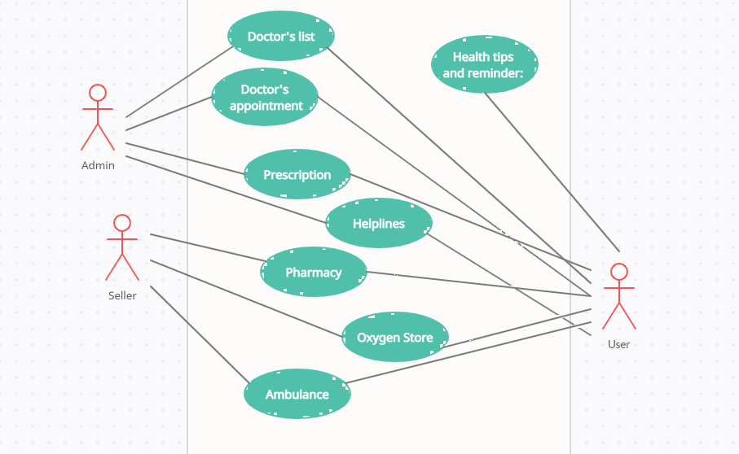

**Implementation Requirements**

Implementation for the our proposed project is divided into some parts

* Used Technology: The main requirements for our project are some web technology

HTML, CSS, Bootstrap, JavaScript, PHP, MySQL, jQuery, Ajax etc.

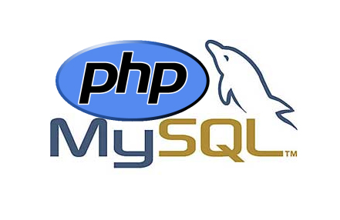 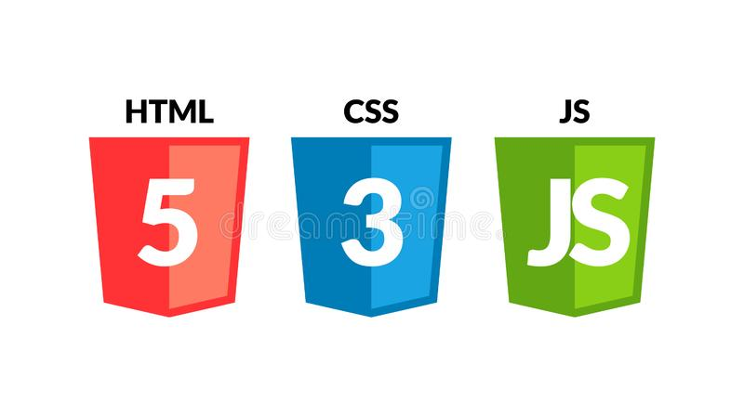 [4] [5]

* Server and Sites: XAMPP, VSS, Web Browser, etc.
* Teamwork: A stable team with active team members.

**Implementation of E-Sheba**

In this section, we have tried to show our whole design interface for a better understanding of the system. Everything will be shown step by step with specific sub-points.

Database

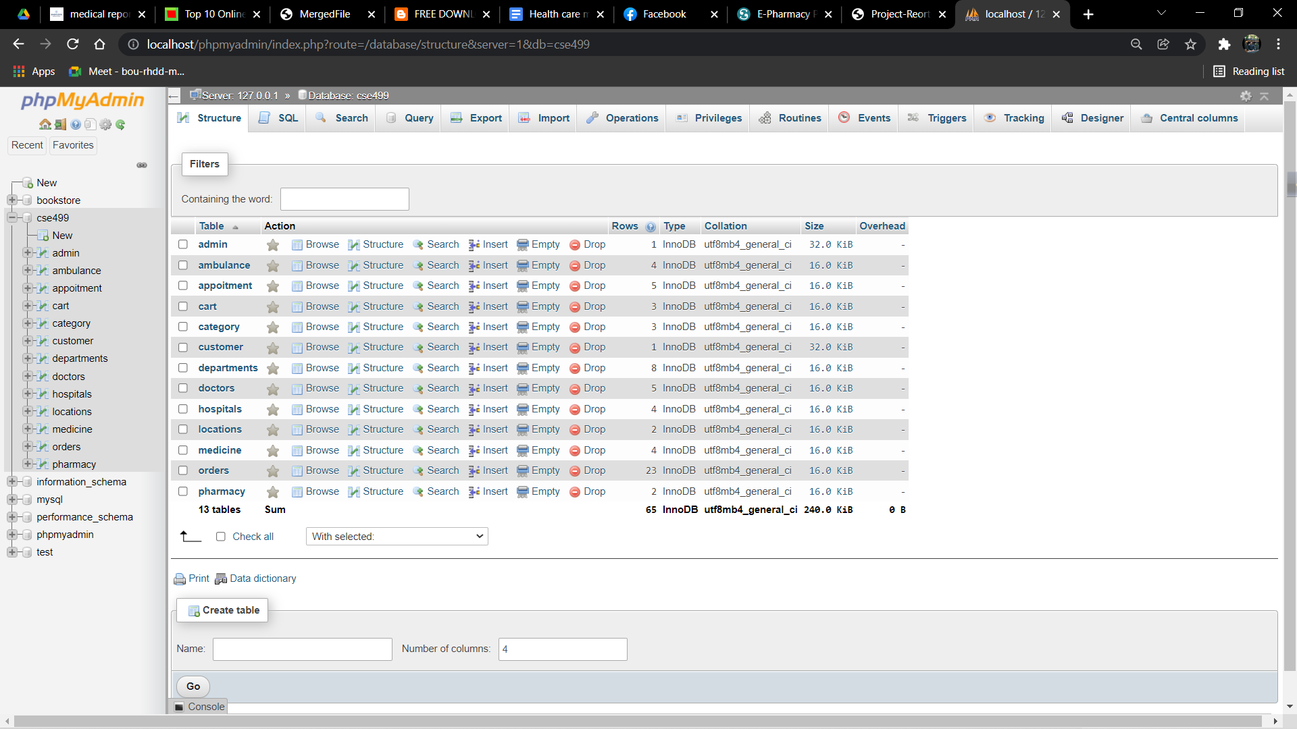

Home

This is the home page of our project. Though we can’t provide the full page image we will try to make you understand some menus we have developed here.

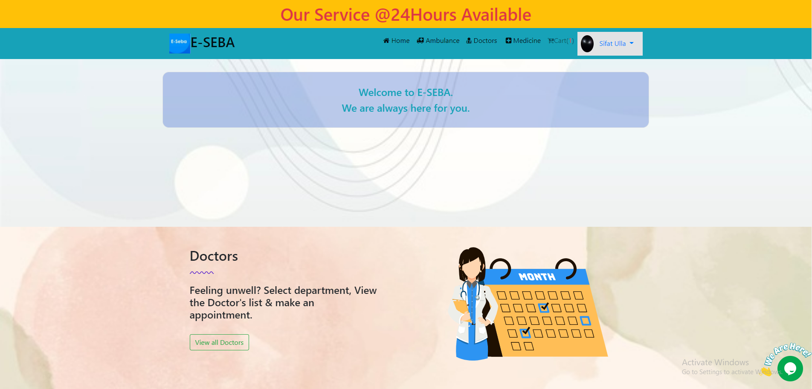

Sign Up

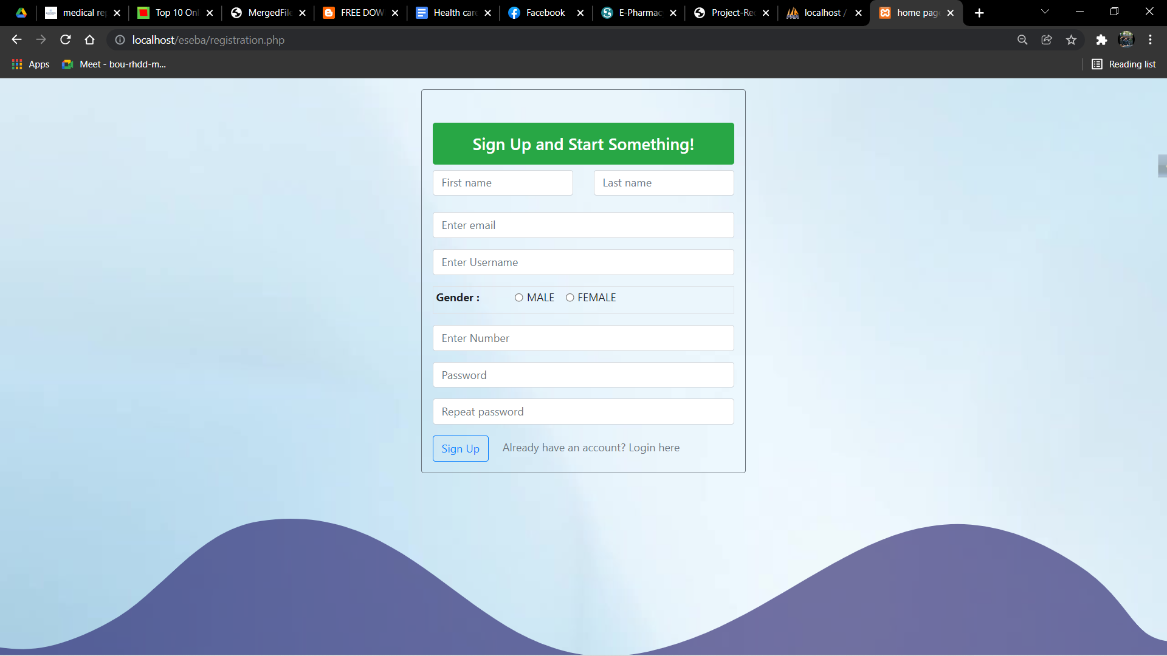

Sign In

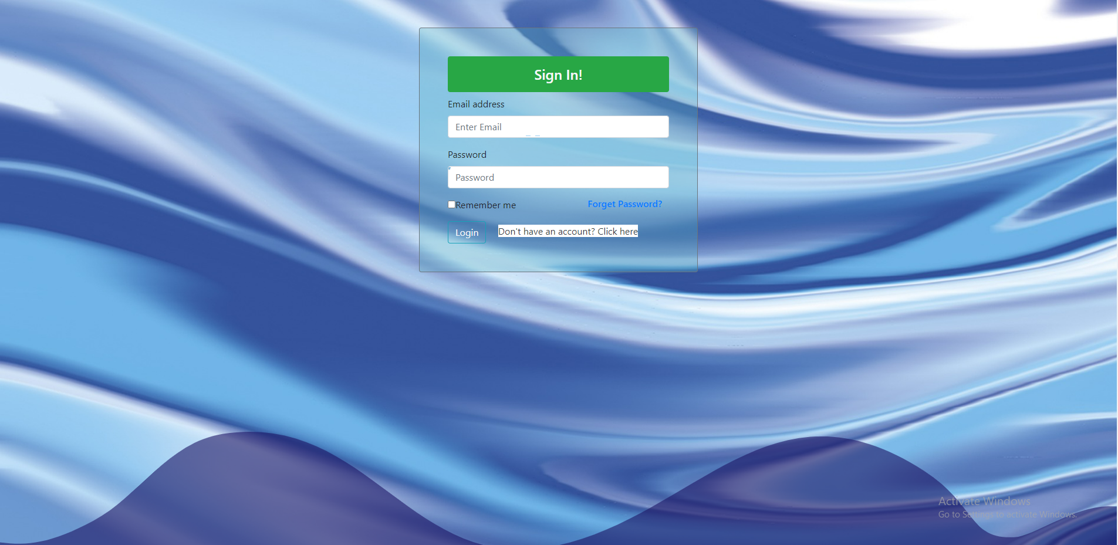

Doctors

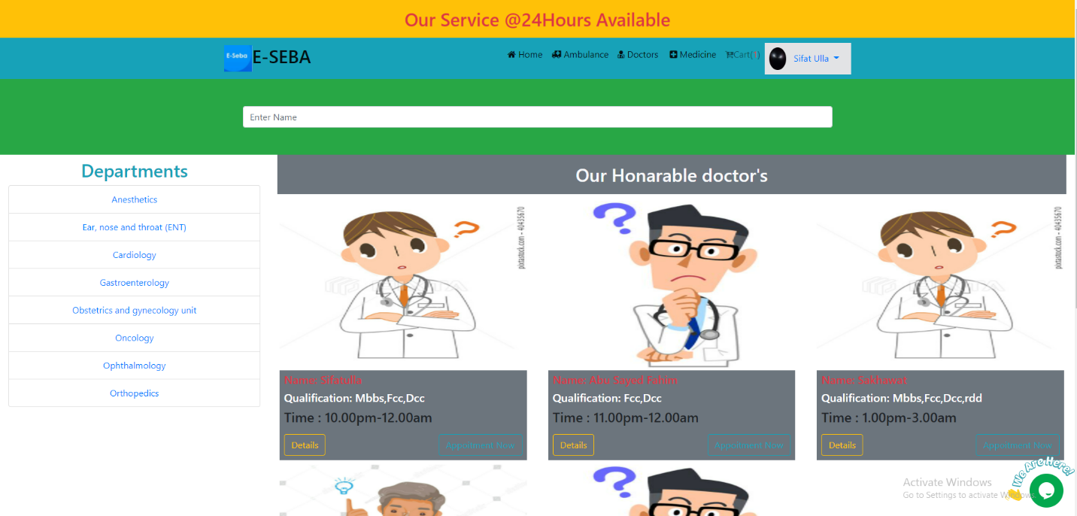

Medicine

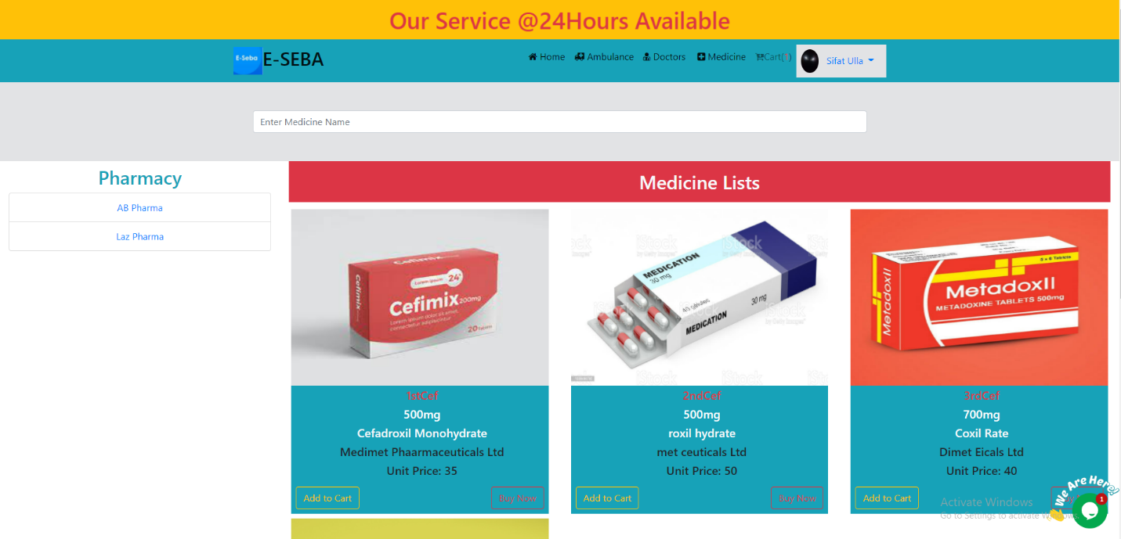

Ambulance

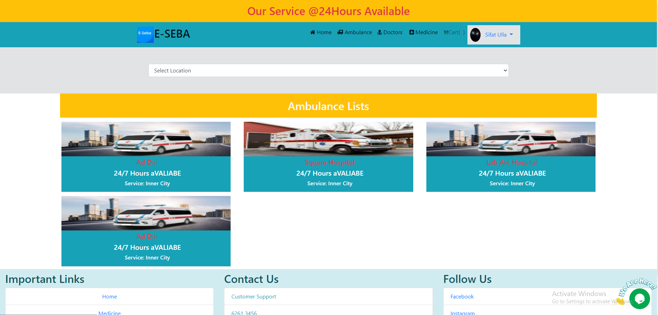

Cart

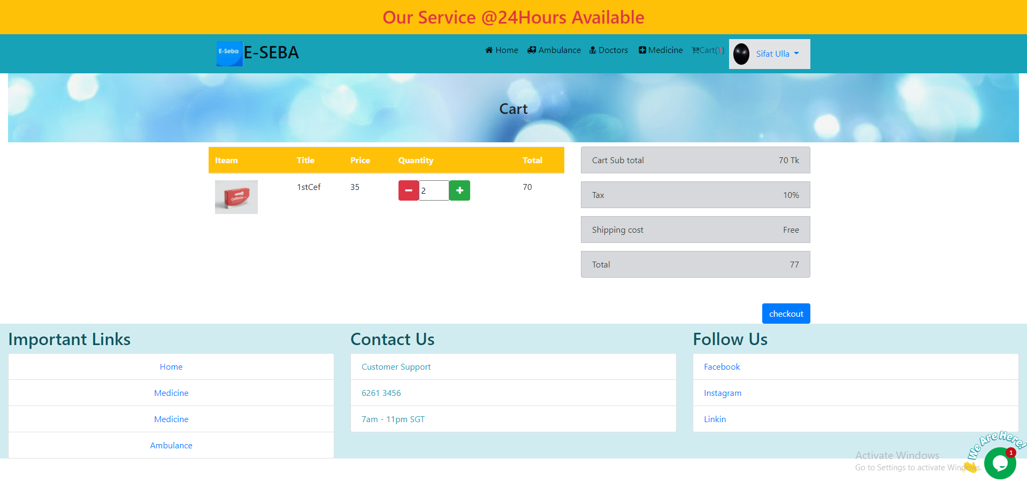

Chatbot

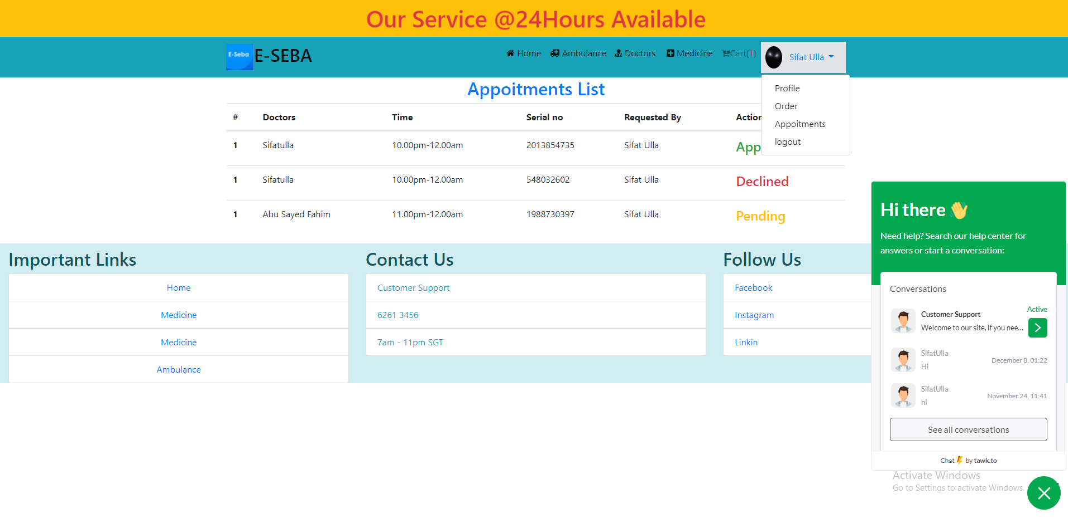

Appointment Status



Payment Method

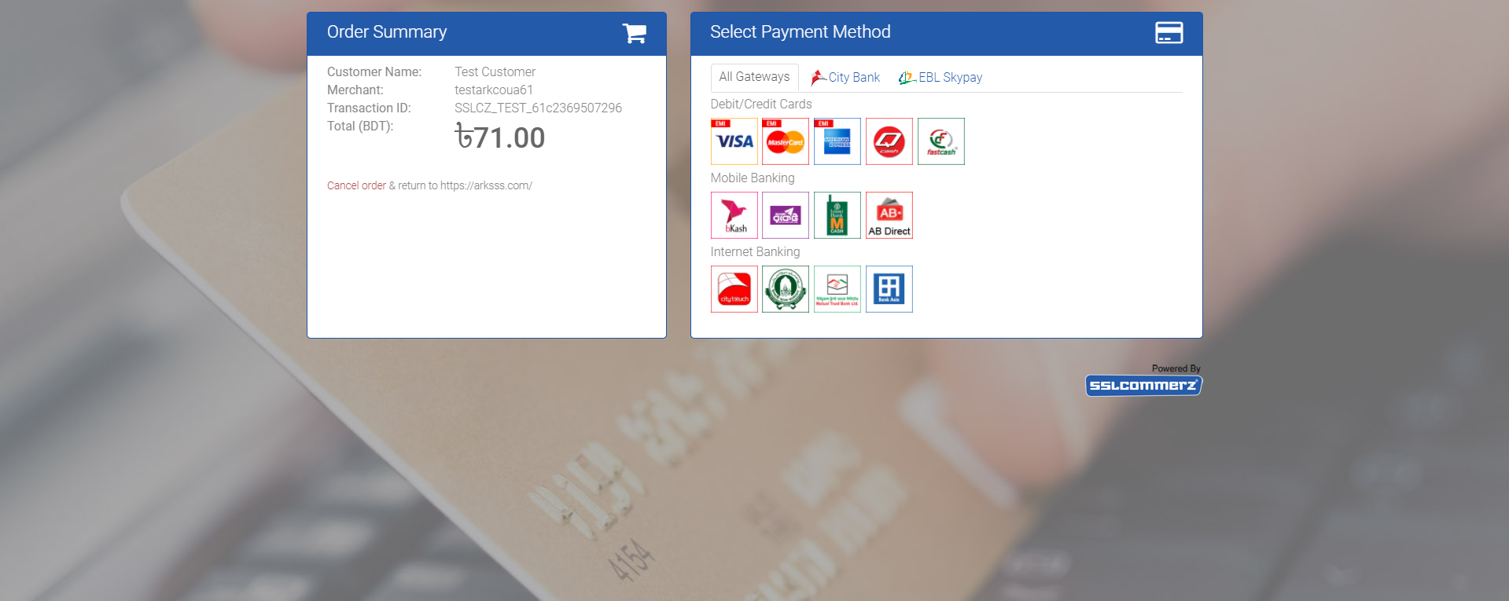

**Conclusion**

As our project is a medical-based project we are hoping it will make a great change to our medical society. In this project, there are so many new and effective portals that are very important. We tried to Add all medical services to one website and the results of our project are so close to it. In Our project, we tried to make it user-friendly and it is user-friendly also. As a start, we tried our best to give this project a handsome shape But some features are needed to be added to complete this project.

**Future Plan**

We are planning to implement more features. Our seller panel is incomplete. So we will complete this in the next part of this course. We will add oxygen store. Then we will work on blood bank service. We will implement a reminder system that reminds the user of their medicine time. We are looking forward to making this web application better & more efficient.

# **References**

|  |  |
| --- | --- |
| [1] | "Research Policy Communication Cell," [Online]. Available: http://rpcc.dghs.gov.bd/rpcc/?wpdmpro=health-system-in-bangladesh-challenges-and-opportunities-by-anwar-islam-and-tuhin-biswas. |
| [2] | "mybangla24," [Online]. Available: https://mybangla24.com/online-doctor-bangladesh. |
| [3] | "Wikipedia," [Online]. Available: https://en.wikipedia.org/wiki/Design_specification. |
| [4] | "Medium," [Online]. Available: https://medium.com/@md.julfikar.mahmud/php-mysql-object-oriented-programming-oop-e88a3dedbae. |
| [5] | "Skywell Software," [Online]. Available: https://skywell.software/blog/how-to-make-a-website-with-javascript-html-and-css/. |